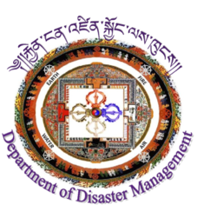
Ministry of Home and Cultural Affairs
Department of Disaster Management
BhutanDisaster Assessment Tool
Household Level Assessment
Explanatory notes for the completion of the household level assessment of needs after disasters in Bhutan.

This household level assessment will be carried out in parallel with the completion of the Bhutan Disaster Assessment for Local Authorities. Both assessments will be consolidated to provide a picture of the damages caused by the disaster and its impact on the people living in affected areas and a report produced within 15 days from the onset of the disaster.
Responsibility for ensuring that this assessment is carried out (if deemed necessary on the basis of the IADS) lies with the Gup/Thromde representative. He/she may designate whichever officials are considered necessary to carry out the assessment.

GENERAL INFORMATION
Dzongkhag: | Household Code Number:
Geog/Thromde: | Assessment Team Members:
Chiwog/Block: | Area description:  Rural  Urban | Date of survey:  (dd/mm/yyyy) | Start time (am/pm):  Finish time (am/pm):
Village name:

P-code/GPS:

General Household Information | Before Disaster | After Disaster
Age and gender of household head: | Male Female  Age: | Male Female  Age:  As Before
Age and gender of informant/s for this assessment | Informant 1: Male Female Age:  Informant 2: Male Female Age:  Informant 3: Male Female Age:
Indicate if any members of the household are in any of the following categories. Beside the category indicate if there have been any problems because of the disaster. | Disabled
 | Elderly
 | Pregnant
 | Lactating
 | Infants (under the age of 12 months)
 | Children under 5

Household priorities and support
What are your greatest problems for your household since the disaster? (Tick top three) |  |  | Water  Sanitation/toilet facilities  Food  Restoration of livelihood activities  Immediate shelter  Repairing damaged house  Clothing, footwear, bedding  Fuel and cooking materials  Health care  Being able to perform cultural and religious rituals  Support for feelings of fear and insecurity  Children returning to school  Transport and access to markets, health care etc  Communication systems  Other (specify)  Other (specify)  Other (specify)
Where do you usually get most support at times of crisis? |  |  | Central Government  Dzongkhag  Gewog  Thromde  YenlagThromde  Community members  Extended family  Nuclear family  Self  Don’t know  Other (name)
WASH (Water, Sanitation and Hygiene)
Question | Before Disaster |  |  |  |  |  |  |  | After Disaster
What was/is the main source of drinking water for your household? | Piped water to dwelling  Piped water to compound  Piped to neighbour  Public tap  Protected dug well  Unprotected dug well  Protected spring  Unprotected spring  Rainwater collection  Tanker-truck  Surface water (river, stream, dam, lake, pond, canal, irrigation channel)  Bottled water  Other (specify) |  |  |  |  |  |  |  | Piped water to dwelling  Piped water to compound  Piped to neighbour  Public tap  Protected dug well  Unprotected dug well  Protected spring  Unprotected spring  Rainwater collection  Tanker-truck  Surface water (river, stream, dam, lake, pond, canal, irrigation channel)  Bottled water  Other (specify)
How long does it take to go there, collect water and come back? | Tick one only  < 10 minutes  10-30 minutes  30 minutes – 1 hour  > 1 hour  Don’t know |  |  |  |  |  |  |  | Tick one only  < 10 minutes  10-30 minutes  30 minutes – 1 hour  > 1 hour  Don’t know
Do you feel you have Is the water sufficient for drinking? | Tick one only  Sufficient  Insufficient  Don’t know |  |  |  |  |  |  |  | Tick one only  Sufficient  Insufficient  Don’t know
Estimate how much drinking and cooking water is available for each household member. | Tick one only  < 3 litres per day  Approximately 3 litres per day  > 3 litres per day  Don’t know |  |  |  |  |  |  |  | Tick one only  < 3 litres per day  Approximately 3 litres per day  > 3 litres per day  Don’t know
How is water treated and in the household? | Tick all that apply  Boiling  Chlorination/bleach  Strain through a cloth  Filtration (ceramic, sand, composite, etc)  Solar disinfection  Let it stand and settle  Covered storage  Other (specify)  Not treated |  |  |  |  |  |  |  | Tick all that apply  Boiling  Chlorination/bleach  Strain through a cloth  Filtration (ceramic, sand, composite, etc)  Solar disinfection  Let it stand and settle  Covered storage  Other (specify)  Not treated
How is water stored at the household level? | Tick one only  Sufficient clean covered water containers available  Insufficient clean covered water containers available |  |  |  |  |  |  |  | Tick one only  Sufficient clean covered water containers available  Insufficient clean covered water containers available
Where are people currently defecating? | Type of toilet |  |  | Adult men | Adult women |  |  |  |  | Male children |  | Female children
 | Open defecation
 | Household toilet
 | Toilet shared with other households that you know
 | Toilet shared with general public
Calculate how many people per functioning communal toilet facility. | Tick one only  < 10  10-20  20-30  > 30
Is there sufficient water for all household members to bath daily, and for hand washing? | Tick one only  Yes for all  For cooking and hand-washing but not for daily bathing  Insufficient water supply for these needs |  |  |  |  |  |  | Tick one only  Yes for all  For cooking and hand-washing but not for daily bathing  Insufficient water supply for these needs
Do you have any soap or detergent (or other locally used cleansing agent) in your household for washing hands? | Tick one only  Yes, bar soap  Yes, detergent (powder/liquid/paste)  Liquid soap  Ash/Mud/Sand  None |  |  |  |  |  |  | Tick one only  Yes, bar soap  Yes, detergent (powder/liquid/paste)  Liquid soap  Ash/Mud/Sand  None
Do you have bathing facilities that offer privacy and security for all household members? | Tick as appropriate  Yes for adult men  Yes for adult women  Yes for boys  Yes for girls  For no one |  |  |  |  |  |  | Tick as appropriate  Yes for adult men  Yes for adult women  Yes for boys  Yes for girls  For no one
Do women in the household have access to sanitary napkins? | Yes  No  NA  Don’t Know |  |  |  |  |  |  | Yes  No  NA  Don’t Know
SHELTER
Question |  |  | Pre-emergency situation |  |  | Post-emergency situation
Is your house damaged? |  |  | No  Yes, minor damage. Grade 1 damage = negligible or slight damage.  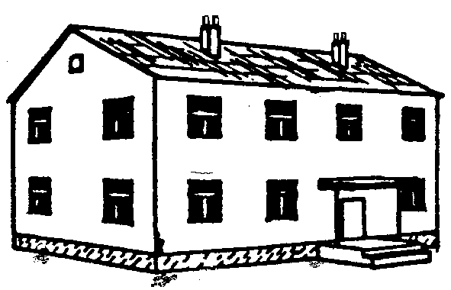  Yes, Grade 2 = slight structural damage, can be repaired.  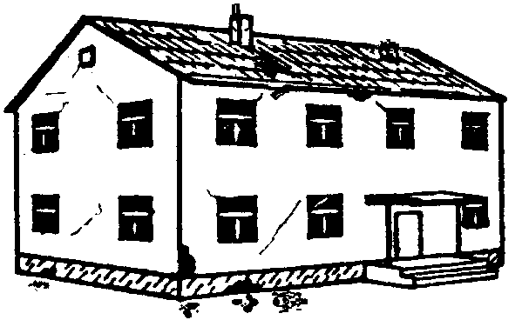  Yes, substantial to heavy damage. Grade 3 = moderate structural damage and heavy non-structural damage.  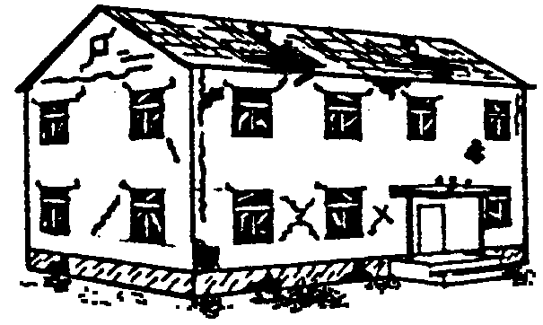  Yes, very heavy damage. Grade 4 = obvious, non-reparable damage.  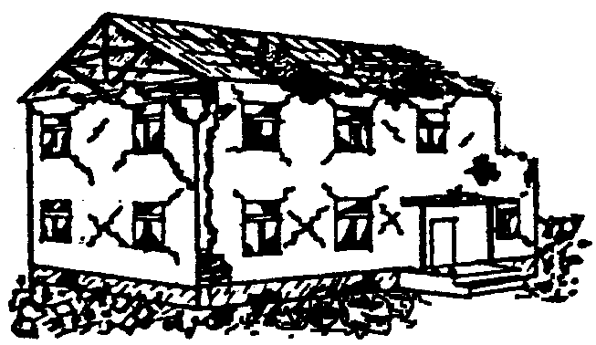  Yes, completely destroyed. Grade 5 = near or total collapse.
What is your present shelter? |  |  | In own house (without damage)  In own damaged house  With neighbours/ relatives/host family  Self constructed temporary shelter  Tent  No shelter  Other, specify:
Are you currently hosting people (extended family, neighbours, others) who do not normally live with you?) |  |  | No  Yes, if yes how many extra people are living with you?
Where are you currently residing? |  |  | Where they lived before (same land)  Displaced but in the same Chiwog/Block as before  Displaced but in the same Gewog/Town as before  Displaced more than 30 min from home
If you have relocated, was this... |  |  | Somewhere you selected yourself  Somewhere you were advised to go to by authorities (e.g based on early warning system).  Other, explain
FOOD and LIVELIHOODS
Question |  |  | Before Disaster |  |  | After Disaster
Has your household received food assistance from the government or some other agency since the disaster? |  |  | Yes  No  Don’t know
Do you normally keep reserves of food at home? |  |  | Yes  No  Don’t know
If yes, how long did/do you expect your food reserves to last |  |  | Tick one only  < 4 weeks  1-2 months  2-4 months  4-6 months  > 6 months |  |  | Tick one only  < 4 weeks  1-2 months  2-4 months  4-6 months  > 6 months
What was the main source of livelihood for this household before the disaster? |  |  | Agricultural & forestry  Mining & quarrying  Manufacturing  Electricity, gas, water supply  Construction  Wholesale & retail trade, repair of motor vehicles and household goods  Hotels and restaurants  Transport, storage & communication goods  Financial intermediation  Real estate, renting & business activities  Public administration & defence  Education  Health and social work  Remittances from overseas  Others, specify:
What is the impact on your family income as a result of the disaster? |  |  | Tick one only  Completely lost  > 76% lost (most)  51-75% lost (a large proportion)  26-50% lost (some, nearly half)  1-25% lost (a little)  None  Don’t know
How long does it take to get to the nearest market? |  |  | Tick one only  < 30 min  31 min-1 hr  1-2 hours  > 3 hrs  Don’t know |  |  | Tick one only  < 30 min  31 min-1 hr  1-2 hours  > 3 hrs  Don’t know  Market not accessible, explain
Does this market sell essential commodities? |  |  | Tick one only  Yes  No  Don’t know |  |  | Tick one only  Yes  No  Don’t know  Market not accessible
Have prices of essential commodities increased since the emergency? |  |  | Tick one only  Yes  No  Don’t know
Do you have enough resources to purchase items? |  |  | Tick one only  Yes  No  Don’t know  NA
How long do you expect these resources to last? |  |  | 1-2 weeks  2-4 weeks  4-8 weeks  8-12 weeks  More than three months  Don’t know
Do you have a functioning stove/place to cook? |  |  | Tick one only  Yes  No |  |  | Tick one only  Yes  No
Do you have sufficient cooking utensils to prepare food for the household? |  |  | Tick one only  Yes  No |  |  | Tick one only  Yes  No
What type of fuel do you use most often for cooking? |  |  | Electricity  LPG  Kerosene  Coal  Wood  Straw, shrubs, grass  Dung cake  No fuel available  No cooking facilities  Other, specify: |  |  | Electricity  LPG  Kerosene  Coal  Wood  Straw, shrubs, grass  Dung cake  No fuel available  No cooking facilities  Other, specify:
Have you had to do any of the following since the disaster? |  |  | Rely on less preferred food  Borrow food  Gifts of food from others (community, family, landlord)  Purchase food on debit  Reduce portion size  Restrict consumption by adults in preference for children  Reduce number of meals eaten in a day  Skip days without eating  Consume seed stocks kept for the next season  Decrease expenditures for fertilizer, pesticide fodder animal feed, vet care  Sell domestic assets (e.g. radio, furniture, fridge, TV)  Sell productive assets (farm implements, sewing machine, motorbike, land, trees)  Sell more animals than usual  Take children out of school  Seek alternative or additional jobs  Increase the number of member out-migrating for work and/or food  Women eat less food than men  Men eat less food than women  Some adult family members left in search of employment  Some child family members left the village in search of employment  No detrimental strategies at this stage  Others, describe:
What type of crops does your household grow? |  |  | NA (not crop growing family)  Rice  Maize  Wheat  Potato  Buck Wheat  Apple  Grape  Others, name:
If the household mentioned crops above: |  |  | Crop |  |  | Percentage destroyed/damaged
 |  |  | Rice
 |  |  | Maize
 |  |  | Wheat
 |  |  | Potato
 |  |  | Buck Wheat
 |  |  | Apple
 |  |  | Grape
 |  |  | Others, name:
Are your crops/land insured? |  |  | Yes  No  Don’t know
What proportion of your land has been affected? |  |  | All  More than half  Less than half  None  Don’t know  Not applicable
Do you own livestock? |  |  | Yes  No
If yes.... |  |  | Type of livestock | Before the emergency |  |  | Number now |  |  |  | Number injured
How many livestock do/did you own? |  |  | Cattle  Yak  Horse  Mule  Donkey  Poultry  Pigs  Sheep  Goat  Buffalo  Fish  Others, (please specify)
What are the constraints in raising livestock as a result of the disaster? |  |  | No food for livestock  No shelter for livestock  Grazing land affected  Other (specify)  No constraints
Prioritize the following agricultural livelihood needs (since the emergency), rank the top 3: |  |  | Storage facilities (for seeds, equipment etc.)  Seeds  Cash  Land compensation  Agricultural inputs/equipment  Restoration of irrigation facilities  Creation of alternate livelihood options  Other, explain  NA
EDUCATION
Question |  |  | Pre-emergency situation |  |  | Post-emergency situation
Do/did children from this household attend school? |  |  | Notapplicable (e.g.No school age children)  Yes  No |  |  | Yes  No
If children did attend school before and are not attending school now, why? |  |  | School facilities destroyed  School has been closed  School facilities are thought not safe (by parents)  Route to the school is not safe/not accessible  Insecurity (e.g. children are afraid to leave parents or return to school)  Parents don’t want to send children to school  Children are needed to help at home  Children are needed to work for income  Teaching/learning materials destroyed (at school)  School uniform/student’s supplies destroyed (at home)  Other, explain:
HEALTH
Is anyone in your HH injured? Yes No

Do you have access to medicine or medical services? Yes No

Do people in your community have access to the following health services?
Delivery services
Basic Obstetric Care
Inpatient Care
Outpatient Care
Others, specify:

Question |  |  | Pre-emergency situation |  |  | Post-emergency situation
How long does it take to get to the nearest health facility? |  |  | < 30 min  30 min- 1 hr  1-2 hrs  2-4hrs  > 4 hrs  Don’t know |  |  | < 30 min  30 min- 1 hr  1-2 hrs  2-4hrs  > 4 hrs  Don’t know
What are the main concerns related to health for this household? |  |  | Please list top three concerns:  1.  2.  3.
Are there any women breast feeding in this household? |  |  | Yes  No
Have there been any changes to feeding of young children since the disaster? |  |  | Breast feeding stopped  Breast feeding reduced  Breast feeding increased  Complementary feeding reduced  Complementary feeding increased  Change of foods  No change  Other, explain:
CULTURE& RELIGION
Does your family usually go to Lhakhangs/Dzongsto offer prayers and blessings? |  |  | Yes  No  Please explain:
Have Lhakhangs, Chortens, Dzongs and other assets related to cultural heritage that are important to this household been damaged due to the emergency? |  |  | Yes  No  Don’t know
Do you feel that a ritual needs to be performed? |  |  | Yes, strongly  Yes  Maybe  No
Performing rituals after the disaster helps a family recover. |  |  | Quickly  Slowly  Not at all  Don’t know/no opinion
PROTECTION
Question |  | Pre-disaster situation |  |  |  |  |  | Post-emergency situation
Is anyone who usually lives with this household missing since the disaster? |  | Yes  No  Don’t know  If “yes”, please record details of missing household members.
Do adult male members of the household feel safe (where you are living)? |  | Yes  No  NA (i.e. no adult men here)  If “no”, please explain: |  |  |  |  |  |  | Yes  No  NA (i.e. no adult men here)  If “no”, please explain:
Do adult female members of the household feel safe (where you are living)?  . |  | Yes  No  NA (i.e. no adult female here)  If “no”, please explain: |  |  |  |  |  |  | Yes  No  NA (i.e. no adult female here)  If “no”, please explain:
Do children who are members of the household feel safe (where you are living)? |  | Yes  No  NA (i.e. no children here, no need to ask the following questions)  If “No”, please explain: |  |  |  |  |  |  | Yes  No  NA (i.e. no children here)  If “No”, please explain:
Do children have more problems sleeping now than before the disaster? |  | Yes  No  Not sure
Are children more aggressive or jittery than they were before the disaster? |  | Yes  No  Not sure
Do children in this house hold work? |  | Yes  No |  |  |  |  |  |  | Yes  No
If yes, is it |  | Paid work  For in-kind support (e.g. food)  To support the family agricultural/livestock/business  Other, explain: |  |  |  |  |  |  | Paid work  For in-kind support (e.g. food)  To support the family agricultural/livestock/business  Other, explain:
Approximately how much time do children spend working? |  | 1-7 hrs per week  7-14 hrs per week  14-21 hrs per week  > 21 hrs per week |  |  |  |  |  |  | 1-7 hrs per week  7-14 hrs per week  14-21 hrs per week  > 21 hrsper week
Do you know of any vulnerable children since the emergency (e.g. children with a disability, children who are unaccompanied by their usual care givers)? |  | Yes  No  If yes, please comment:
Have you seen or heard of people being verbally or physically badly treating children since the emergency? |  | Yes  No  If yes, please comment:
Explain any coping strategies that people in this household are using to deal with the trauma of the disaster.. |  | Explain:
Are you concerned about the security of your possessions? |  | Yes  No  If “yes”, explain:
Do you face any problems/conflict/tension? |  | Yes  No  Does not want to answer |  |  |  |  |  |  | Yes  No  Does not want to answer
If yes, please indicate the sources of the tension. |  | Neighbours  Displaced groups come to reside nearby  Host community  Does not want to answer  Other, explain: |  |  |  |  |  |  | Neighbours  Displaced groups come to reside nearby  Host community  Does not want to answer  Other, explain:
TRANSPORT and COMMUNICATION
Question |  |  | Pre-emergency situation |  |  |  |  |  | Post-emergency situation
Do you have electricity where you are staying? |  |  | Yes  No |  |  |  |  |  | Yes  No
What working means of communication do you have access to? |  |  | Fixed telephone in own home  Mobile  Access to neighbour’s fixed telephone  Access to neighbour’s mobile  Nothing  Don’t know  Other, explain: |  |  |  |  |  | Fixed telephone in own home  Mobile  Access to neighbour’s fixed telephone  Access to neighbour’s mobile  Nothing  Don’t know  Other, explain:
What is the best way for your household to get information since the disaster? |  |  | Word of mouth  Newspaper  Radio  SMS/text messaging on mobile  Local leaders (e.g. Gup, Gewog staff)  Other, explain:

Not all disasters are “sudden onset” and the 15 day time frame may need to be considered flexibly for disasters that get worse over time, such as floods, where a disaster is worse than originally thought, or where accessibility and communication are particularly difficult.

